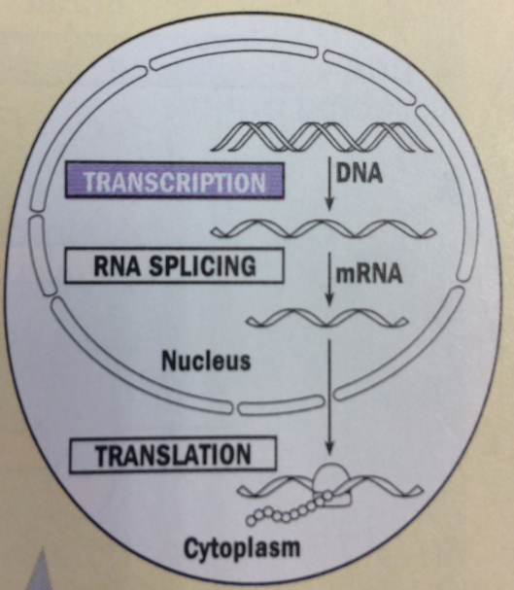

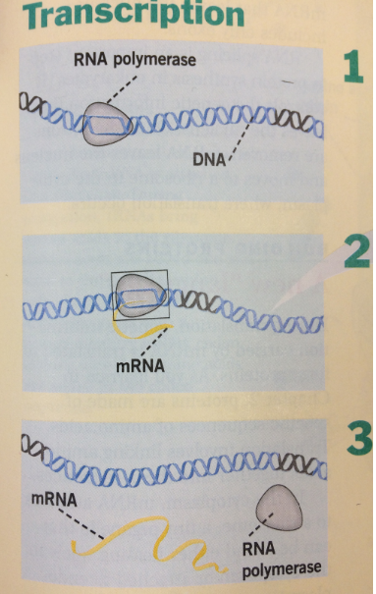

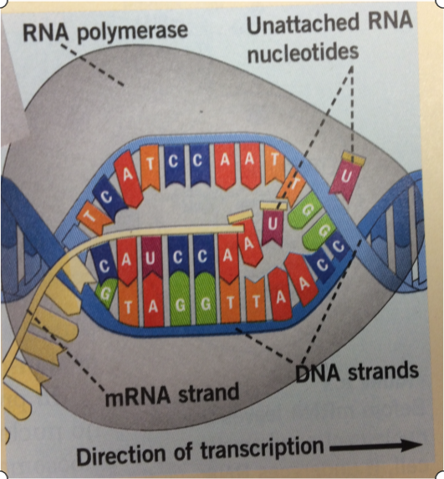

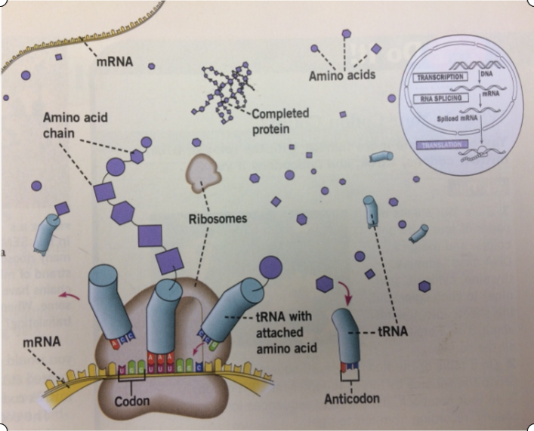

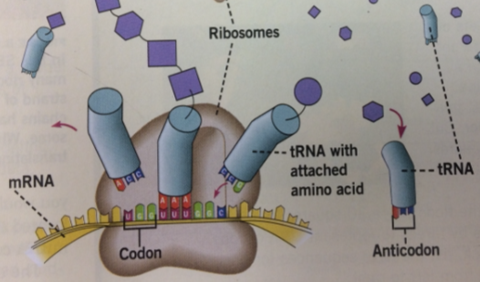

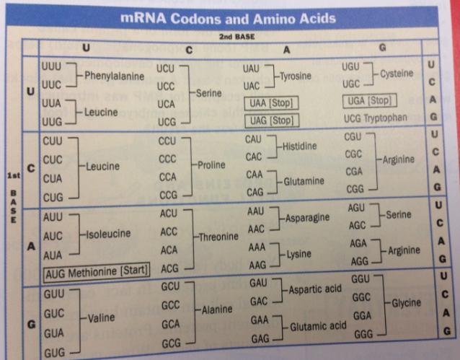

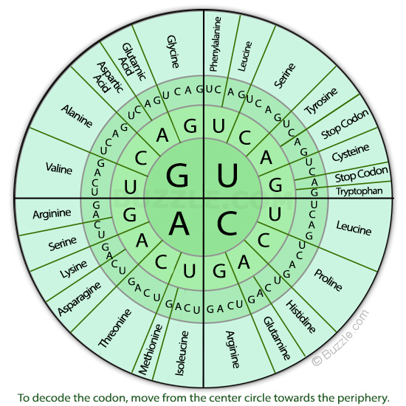

Name: ___________________________________________________________ per. ____________

TRANSCRIPTION: LABEL PRACTICE



TRANSLATION: LABEL PRACTICE

