April 10, 2014 THE FINANCIAL TIMES

ExxonMobil fracking fluid aims to curb environmental impact By Jeevan Vasagar
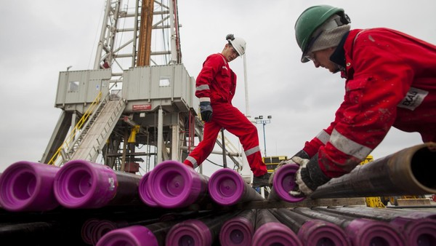©Bloomberg
ExxonMobil is stepping up its attempts to win over sceptical Europeans to fracking by developing a generation of hydraulic fracturing fluids that do not pose a hazard to the environment.
The US group, the world’s biggest private sector oil company by market capitalisation, said it had developed non-toxic fluids specifically intended for the geological conditions in Germany. The fluids have yet to be tested under field conditions.

According to research, the chemicals used in fracking in the US, which are blended with sand and water and pumped into the ground to fracture gas-bearing rock, are potentially harmful to the health of humans and wildlife.
Researchers at the University of Missouri, in a study published in a peer reviewed journal, found that chemicals commonly used in fracking can disrupt hormones that regulate body functions including reproduction.
Companies including Exxon have been granted permits to search for the fuel in Germany, which has up to 2.3tn cubic metres of recoverable shale gas, according to an estimate by a government geosciences institute.
Germany’s estimated reserves are significantly smaller than those of Poland and France, which have the biggest recoverable reserves in Europe, according to estimates by the US Energy Information Administration. But Germany’s reserves have the potential to provide a long-term domestic energy supply.
Energy-intensive German manufacturers have watched the US shale boom with envy, and there is increasing concern that Germany needs to find an alternative to its reliance on Russia, which meets about a third of its gas demand.
However, Angela Merkel’s coalition government has placed a moratorium on fracking, citing environmental concerns.
The coalition agreement says applications for fracking may only be authorised if it is “clarified beyond doubt” that there is no risk to water quality, and that environmentally harmful chemicals may not be used.
Michael Fuchs, deputy leader of Ms Merkel’s Christian Democrats in the Bundestag, recently called for the “advancement of [fracking] pilot projects” and said Germany should not label it a risky technology like nuclear power.
His comments provoked an argument in the ruling coalition, with the environment minister Barbara Hendricks, a member of the Social Democrats, describing the prospect of fracking as “wishful thinking” in a country as densely populated as Germany.
Exxon in Germany confirmed that it had developed fracking fluids that were neither toxic nor hazardous to the environment. Asked what impact this might have on the political debate, Exxon declined to comment.
Halliburton, the oil services company, also said it had developed fracking fluids sourced from the food industry that provide an “extra margin of safety” to people, animals and the environment. The Halliburton formulation is in use in at least one well in the Haynesville Shale formation in the southern US.

