Last updated: June 4, 2015 11:15 pm

US agency finds no widespread fracking impact on drinking water
Barney Jopson in Washington and Ed Crooks in New York

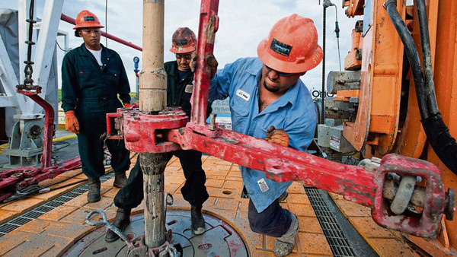©Bloomberg
The US environmental regulator has concluded there is no evidence that “fracking”, the technique used to produce shale oil and gas, has caused “widespread” pollution of the country’s drinking water.
But, in a long-awaited study, the Environmental Protection Agency also acknowledged a small number of contamination cases, and said its conclusions on hydraulic fracturing were not definitive due to a lack of data.

The study leaves the way clear for continued use of the technique, which has made possible the spectacular revival of US oil production and upturned the world energy market in the past five years.
Its conclusions will be closely studied not only in the US but in other countries with shale oil and gas resources that are also debating whether fracking is safe, including the UK and Germany.
The 998-page study provided ammunition for both supporters and opponents of fracking in the US, with the oil industry saying it proved it was safe, and environmentalists arguing it confirmed its dangers.
The regulator said: “While hydraulic fracturing activities in the US are carried out in a way that have not led to widespread, systemic impacts on drinking water resources, there are potential vulnerabilities in the water life cycle that could impact drinking water.”
The EPA said it hoped the study would help politicians, the industry and the public, decide “how best to protect drinking water resources now and in the future”.
The onus is on state policy makers who lead regulation of the oil and gas industry, partly because a 2005 law associated with Dick Cheney, then US vice-president, limits the federal government’s power over fracking.
States have taken divergent approaches. Texas and North Dakota, two engines of the shale boom, have done little to stand in the industry’s way. But New York has banned fracking due to worries about its health effects.
Fracking involves pumping a mixture of water, sand and chemicals into wells at high pressures to open up fissures in rocks that allow oil and gas to escape.
Barry Rabe, professor of public policy at the University of Michigan, said: “This study is likely to keep vigilance over concerns about water fairly high. It may be that states require more testing of water before and after fracking.”
But he added that it may not shift opinions much in states where policy makers have already taken a firm stance for or against the practice.
The EPA was asked by Congress to study fracking in 2010, and formalised its investigation into drinking water in 2011.
In its study, the EPA said it could not be sure whether the small number of pollution cases meant that effects on drinking water were genuinely very rare, or whether they had been underestimated due to factors such as inadequate monitoring of water quality.
The US oil and gas industry said the investigation showed that fracking was safe.
Statoil and ExxonMobil chiefs call on EU to allow fracking
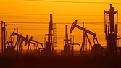
European laws restricting fracking have come under attack from the chief executives of two of the world’s largest oil and gas companies who are calling on policy makers to re-examine the contentious drilling process. Eldar Sætre, the chief executive of Norwegian state-controlled energy company Statoil, told the Financial Times that fracking was currently a “lost opportunity” for Europe.
Continue reading
“The evidence gathered by EPA confirms what the agency has already acknowledged and what the oil and gas industry has known,” said Erik Milito of the American Petroleum Institute. “Hydraulic fracturing is being done safely under the strong environmental stewardship of state regulators and industry best practices.”
Michael Brune, of the Sierra Club, an environmental group that campaigns against gas production, took the opposite view, saying the study “confirms what millions of Americans already know — that dirty oil and gas fracking contaminates drinking water”.
He also criticised the EPA for having chosen “to leave many critical questions unanswered” in the study.
The EPA estimated that 25,000-30,000 wells were fracked in the US each year, and said some of them had led to pollution of drinking water through several different routes, including leakage of oil and gas into underground water resources and improper disposal of the flowback water that comes out of shale wells along with produced oil and gas.
It suggested there could be 100-3,700 spills of fracking fluids or other chemicals used in shale gas production in the US each year.
However, the EPA added, not a single such spill reported to the agency had so far been discovered to have reached groundwater.
Another part of the federal government, the Department of the Interior, introduced new environmental safeguards on fracking on public land in March.
But the federal government has little control over activity on private land due to what environmentalists have dubbed the “Halliburton loophole”, a provision of the 2005 law named after the oil company that Mr Cheney once led.

