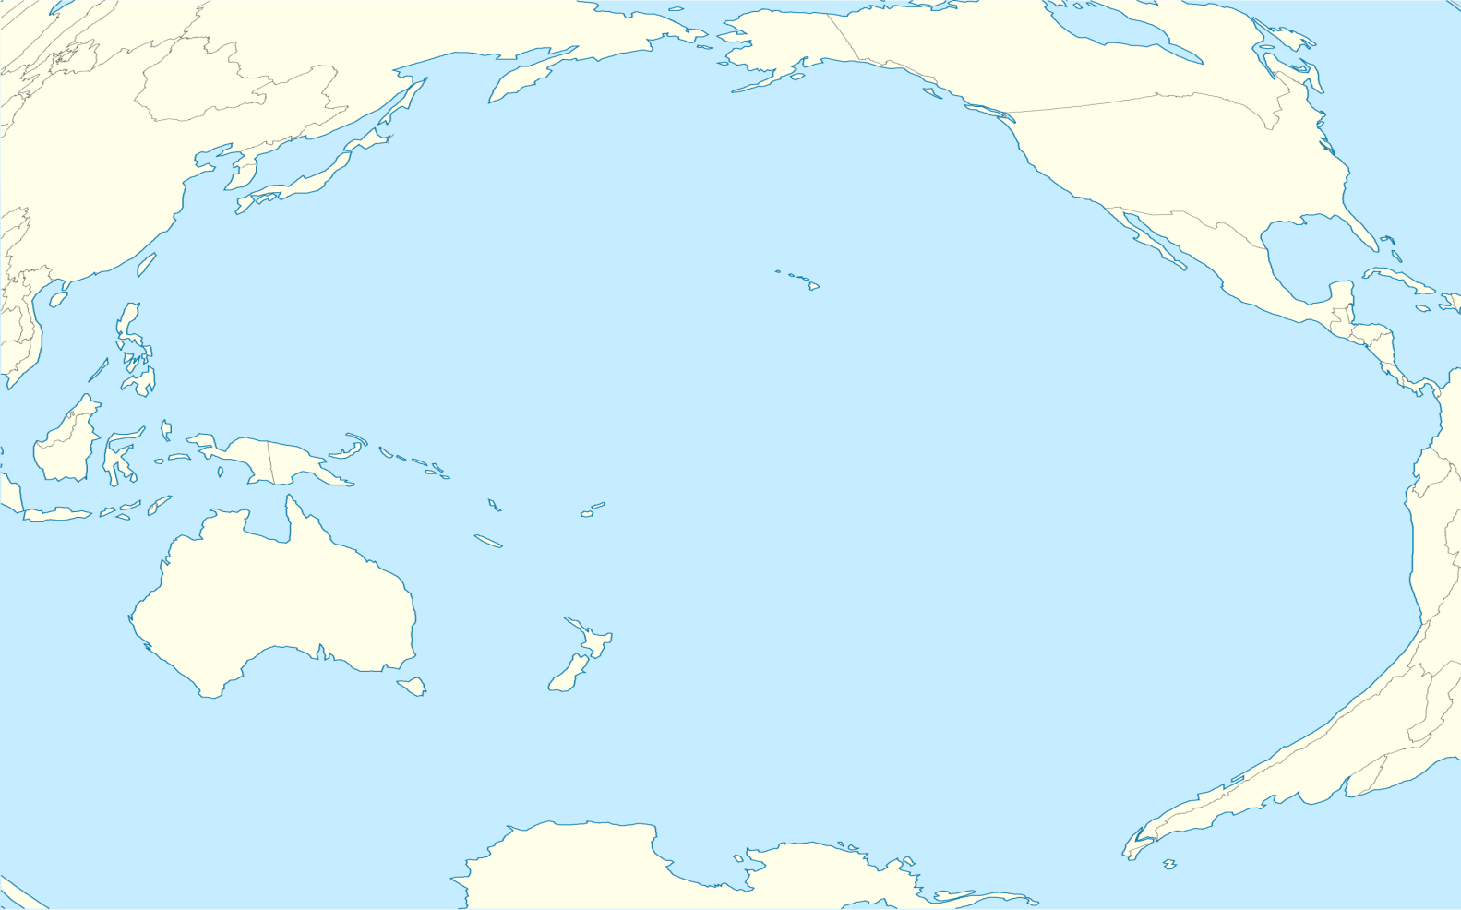

On a globe point to each of the following problems that often occur as a result of El Nino.

