Name: _____________________________________________________ per: ____________

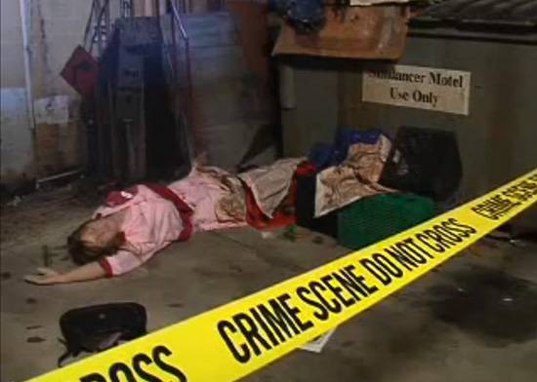

**DRUG TESTING: At the scene…**  These are ____________________________________ tests, also called ___________________________________ tests.

***Marijuana and Hashish products***

The _____________________________ test detects __________,

and turns __________________ when positive.

***Powders, Pills and Crystals***

The ____________________________ test detects many different

chemicals and turns ___________________ for ______________,

and purple for __________________________.

Brand names for this test include the _______ test and the __________ .

= SAMPLE sent to the LAB

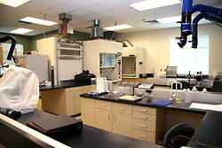 = SAMPLE arrives from the CRIME SCENE

***Marijuana and Hashish products***

Green plant material is confirmed under a ___________________ which shows

______________ that resemble ________________.

**DRUG TESTING: In the LAB…**  These are _______________________________tests, which either agree or disagree with the original (preliminary / presumptive) result.

Since ***all drugs*** are a __________________ of compounds, we use

____________________________ to separate the different compounds into

________________. The sample dissolves in a _____________________ and the

compounds (or “ingredients”) spread out according to molecular size.

under a ______________________

using the MICRO -________________________

test.

***Cocaine and Methamphetamines* look like:**

and 

***ALL DRUGS…*** Like people, drugs have a unique ________________________ or ____________________ , so this test is called IR DRUG _________________________. The substance is first dissolved in _________________. Then ____ waves, like visible light, can be “pointed at” the substance. Each substance ___________________ back wavelengths of radiation – and that is their “signature.” 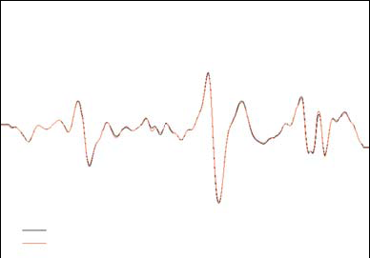 or 