A massive diversionChina has built the world’s largest water-diversion project
Channelling water from south to north does more harm than good
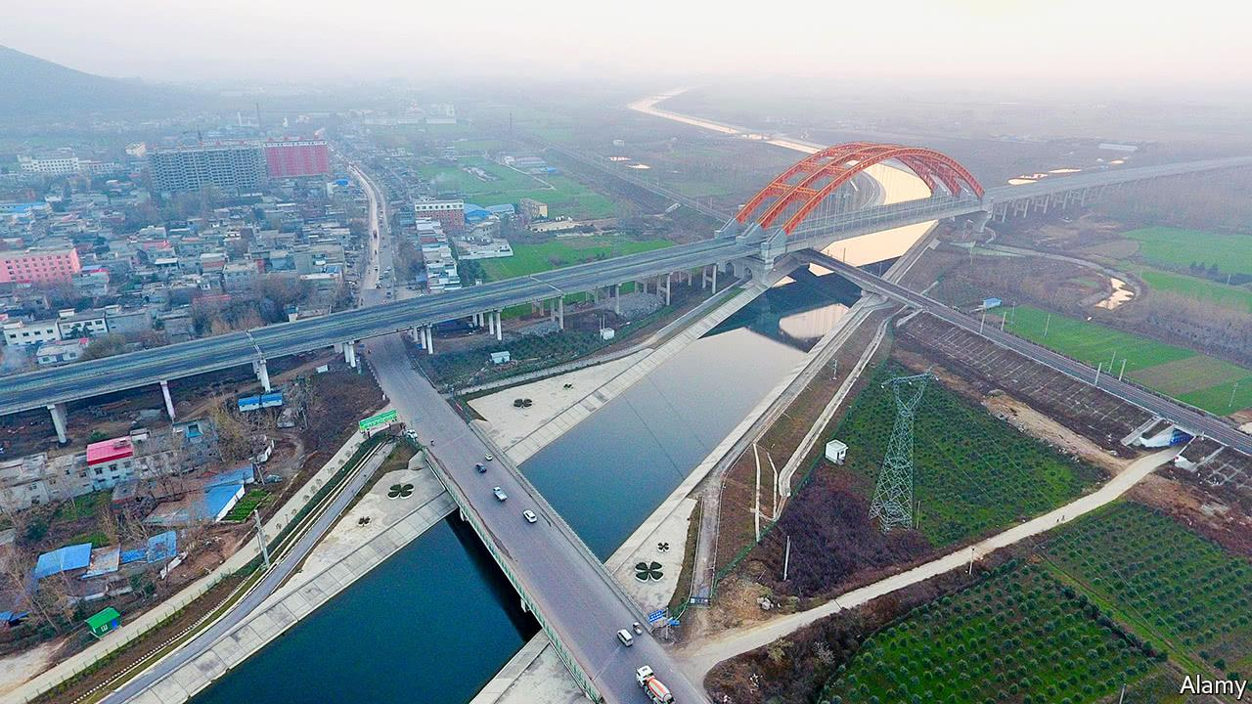

Print edition | China
Apr 5th 2018| BEIJING AND DANJIANGKOU
FOR the past drought-stricken year, most of the drinking water consumed in Beijing has travelled 1,432km (895 miles), roughly the distance from New York to Orlando, Florida. Its journey begins in a remote and hilly part of central China at the Danjiangkou reservoir, on the bottom of which lies the drowned city of Junzhou, reputed to be the birthplace of Taoism. The water gushes north by canal and pipeline, crosses the Yellow river by burrowing under it, and arrives, 15 days later, in the water-treatment plants of Beijing. Two-thirds of the city’s tap water and a third of its total supply now comes from Danjiangkou.
This winter and spring, the reservoir was the capital’s lifeline. No rain or snow fell in Beijing between October 23rd and March 17th—by far the longest drought on record. Yet the city suffered no supply disruptions, unlike Shanxi province to the west (see map), where local governments rationed water. The central government is exultant, since the project which irrigates Beijing was built at vast cost and against some opposition. But the self-congratulation is not warranted.
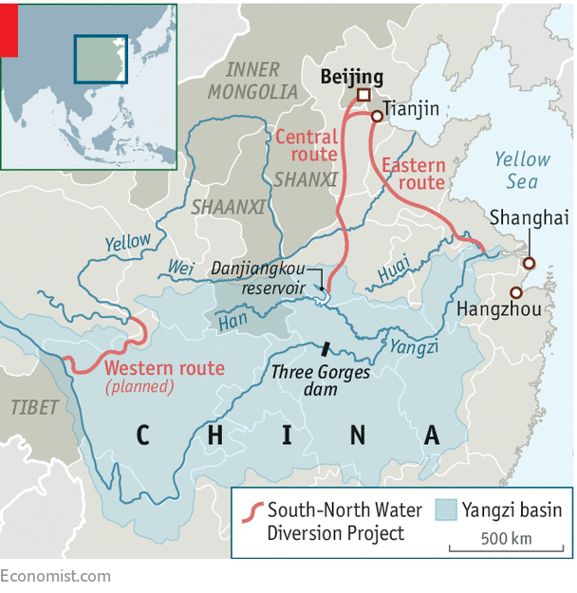
The South-to-North Water Diversion Project—to give the structure its proper name—is the most expensive infrastructure enterprise in the world. It is the largest transfer of water between river basins in history, and China’s main response to its worst environmental threat, which is (despite all the pollution) lack of water.
Four-fifths of the country’s water is in the south, where half the population lives. But in the north, 11 provinces have less than 1,000 cubic metres per person per year, which is the internationally accepted measure of water stress. Eight have only half that amount. The arid ones include four of China’s five biggest farming provinces. They produce 45% of the country’s GDP and generate half of its power. It is no exaggeration to say the future of China’s economy is threatened by lack of water.
From where it all flowed
Back in 1952 Mao Zedong concluded that “the south has plenty of water, the north much less. If possible, the north should borrow a little.” The project does this by linking the Yangzi river in the south with regions to north. The route between Beijing and Danjiangkou, which lies on a tributary of the Yangzi, opened in 2014. An eastern route opened in 2013 using the ancient Grand Canal between Hangzhou and the capital. (Jaw-dropping hydrological achievements are a feature of Chinese history.) A third link is planned on the Tibetan plateau, but since that area is prone to earthquakes and landslides, it has been postponed indefinitely.
The whole project, if ever completed, would transfer up to 45bn cubic metres of water a year, or 7% of China’s water consumption. The two working stretches can divert 25bn tonnes of water annually from south to north. So far these have cost, according to the project’s first director, Zhang Jiyao, 300bn yuan ($48bn)—more than twice their initial budget.
The project was controversial from the start. In a rare example of public criticism, China’s vice-minister for housing, Qiu Baoxing, called it difficult to sustain and unnecessary if China would only stop wasting water. Ma Jun, China’s foremost environmentalist, warned that it would increase pollution (which was already bad) and claimed the mere expectation of the project was causing northern cities to use water recklessly. They were depleting local supplies, he thought, because they knew the inundation from the south would one day rescue them.
Officials dismiss such worrywarts. The first years of operation, they claim, show the project to be an unqualified success. More than 50m people, according to the water ministry, have been supplied by the system. The water table under Beijing had been subsiding at an alarming rate of between one and three metres a year because of pumping from wells. This has slowed. The project has revived severely eroded ecosystems nearby, such as Lake Juyanhai in Inner Mongolia, which had dried up in 1992. It also promises to boost GDP by 0.1-0.3 percentage points, since economic activities once constrained by water shortages are now able to run normally. But this is hard to measure.
A triumph, then? Hardly. In reality, the project has not solved water shortages in Beijing. Nor has it dealt with the country’s real problems. It has also added difficulties of its own. At best, it buys a little time in which to get water policies right.
The capital uses about 3.6bn cubic metres of water a year. The city has 2.1bn in local reservoirs and rivers, and the diversion scheme provides 1.1bn. So the project does not cover the current shortfall, which is made up by underground water. As the capital’s population and economy grow, its water consumption could rise to more than 4bn cubic metres a year by 2020. If that happens, and assuming the scheme runs as advertised, it would plug only two-thirds of the gap. In north China as a whole, water demand is forecast by the government to reach 200bn cubic metres by 2050. The two parts of the water project built so far would cover just one-eighth of that. In short, the project would not solve north China’s water shortages even if it were working as planned.
But it is not. Officially, 9.5bn cubic metres of water a year are supposed to be flowing through the middle route. But officials at the headwaters in Danjiangkou say that less than half of the planned extraction was taken out of the reservoir in 2017. This is partly because the price of reservoir water is high and therefore demand has been lower than expected. But it is also because the reservoir is relatively small: its capacity is 29bn cubic metres. Taking a third of that away each year, engineers worry, would stir up huge quantities of silt.
The capital still gets almost all the water it was promised. But the provinces surrounding it get barely a third. When the project was designed, officials were at pains to argue that all north China would benefit. In practice, the project has been largely a water-delivery system for the capital. Since Beijing is one of the wealthiest parts of China and the area around the reservoir is relatively backward, the project takes from the poor and gives to the rich.
Given that the project is operating at less than its capacity, it might be supposed that it would be causing less damage. Not so. More than 380,000 people had to be moved to make way for the rising waters. Because planners worried about pollution, they closed many of the industries lining canals and reservoirs. These included the mainstays of Danjiangkou’s economy: fish farming and turmeric processing. The result has been high resettlement costs and a reduced tax base.
Li Xuanxiu is one of those resettled. Tending her cow and calf beneath tangerine trees near an abandoned village, she says she had to move twice when the government raised the reservoir’s level. Zhao Keqian, from a nearby village, says people understand the aim of the project but not the way the local government handled it. “The government doesn’t care about us,” he complains, matter-of-factly.
Mr Zhao says local officials paid him 450 yuan per square metre for his old house but charged 1,000 yuan per square metre for his new one. The government also took 40% of what it paid him for his land, claiming this was really the government’s. Those rehoused, Mr Zhao thinks, end up with a new house, no savings, no job and 600 yuan a year of income support—not nearly enough to live on.
Downstream from Danjiangkou, pollution has proved intractable. By diverting water from the Yangzi, the project has made the river more sluggish. It has become less able to wash away contaminants and unable to sustain wetlands, which act as sponges and reduce flooding. To compensate for water taken from their rivers, local governments are also building dams wherever they can to divert it back again. Shaanxi province, for example, is damming the Han river to transfer water to its depleted river Wei.
Worst of all, the project diverts not only water but money and attention from China’s real water problem: waste and pollution. In 2017 water in nearly one-tenth of samples taken from the Yellow river was deemed unfit even for farming. The land ministry says that half the groundwater in the north China plain is too dirty for factories. In Europe 80% of water in industrial processes is recycled. In China the share is half that. In 2015 a study in Nature magazine by Jon Barnett of the University of Melbourne found that China did not need the project. It could be self sufficient, he argued, if it saved water and cut pollution.
To give credit where it is due, the government has started to increase water prices to discourage waste. The project is playing a role. At the end of 2017 a new tariff system went into effect in nine of the 11 water-stressed provinces. Water from the diversion project is pricier than that from local sources, which in theory should mean it will encourage conservation. The trouble is that basic tariffs are still too low. The higher cost of diverted water is borne not by consumers but local governments (such as Beijing’s). So the project has no direct effect on usage. On top of that, urban water infrastructure has long been neglected. Sewers back up, pipes leak. Instead of trying to fix them and rein in demand, China is focusing on boosting supplies.
The South-to-North Water Diversion Project is a test for Xi Jinping, China’s president. He frequently argues that China must stop blindly increasing GDP at the environment’s expense. And he appears to recognise that the Yangzi basin needs protecting. Under a government reorganisation in March, the environment ministry took over supervision of the diversion scheme. Its new overlords should heed the advice of Mr Zhang, the project’s first director. “The solution to China’s water-supply problem is conservation,” he said in 2013. “Using water diversion to sustain economic development is a dead end.”
This article appeared in the China section of the print edition under the headline "A massive diversion"

