Why Biodiversity Matters AP BIOLOGY
There are both practical and moral arguments for preserving biodiversity. From a practical point of view, humans derive many kinds of food, medicine, and fuel from plant and animal sources. All food crops were originally domesticated from wild species. More recently, researchers have derived anticancer drugs from the bark of the Pacific yew tree and from the Madagascar periwinkle flower. Scientists are currently working to isolate enzymes from a diversity of microbes that can digest plants for human use as transportation fuels. Many existing species that we know little about—especially insects, fungi, and microbes—may yield similarly important products.
Natural resources also provide jobs and income to many communities. Roughly 40,000 jobs were lost in Newfoundland in the 1990s when North Atlantic cod stocks collapsed due to over-fishing. Protecting biodiversity helps to ensure that crops, fisheries, and animal stocks will have enough genetic variety to survive natural disasters and diseases. When new diseases strike common crops, genetic stocks derived from wild relatives can be used to identify traits for resistance to the new infestations. This is the rationale for protecting areas that harbor wild relatives of domesticated plants and for creating stock centers that maintain seeds from wild relatives. For example, the C.M. Rick Tomato Genetics Resource Center at the University of California at Davis is a repository for wild and mutant strains of tomato and provides seed samples for research worldwide (footnote 21).
Healthy ecosystems also provide many other important services to human communities. These functions are so basic that they can go unnoticed, until they disappear. The American Dust Bowl occurred in the 1930s because repeated plowing and cultivation across the Great Plains broke up the cover of prairie grasses (viewed as weeds by farmers) that held the soil in place. Several years of extreme drought left the plains vulnerable to wind erosion, which blew topsoil off millions of acres and displaced thousands of farming families (Fig. 13).
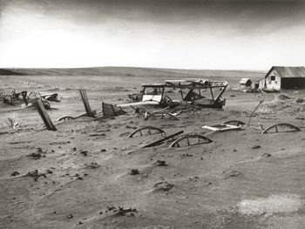
Figure 13. Buried machinery in barn lot, Dallas, South Dakota, 1936
Source: � United States Department of Agriculture.
In the past several decades, societies have begun to recognize the economic value of ecosystem services. For example, New York City signed an agreement in 1997 with state and federal agencies and 80 upstate communities to buy and protect lands in the Catskill and Delaware watersheds, which supply about 90 percent of the city's drinking water. By spending $1.4 billion on land acquisition and related measures to reduce pollution in the target areas, New York avoided building a $6–8 billion filtration plant to purify water from these sources(footnote 22).
Concerns about global climate change have increased awareness of the role that ecosystems play in sequestering carbon from the atmosphere and are spurring investment in programs to preserve this service. The World Bank's Prototype Carbon Fund (PCF), which invests in projects that reduce greenhouse gas emissions and promote sustainable development, is supporting ecosystem protection initiatives including native forest restoration in Brazil, soil conservation in Moldova, and afforestation (planting new forests) on degraded agricultural land in Romania. Under procedures outlined in international climate change agreements, each of these projects will generate economic credits for reducing carbon dioxide emissions—a mechanism that effectively monetizes the benefit that the ecosystems provide by taking up atmospheric carbon dioxide in plants. By purchasing these credits, PCF will give local agencies a financial incentive to carry out the projects. The bank hopes to spur similar commitments from private investors that will help to create a market for carbon credits.
If ecosystems provide such valuable services, why do many communities exploit and damage them? First, valuing ecosystem services is a relatively new concept, and there are many different approaches to estimating those values. Second, local communities often have more to gain from quick exploitation than from conservation unless they receive special incentives, such as premium prices for sustainably-produced products. Third, existing incentives may reward communities that develop ecosystems instead of conserving them. For example, many U.S. communities encourage commercial development because it generates property taxes, even though this development reduces open space and increases traffic and pollution (footnote 23). The development pictured in Fig. 14 threatens the habitat of the Douglas County pocket gopher, which is endemic to the area.

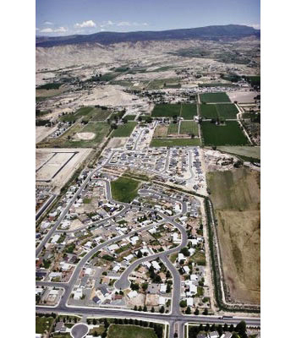
Figure 14. Suburban development in Douglas County, Colorado

Many advocates also make aesthetic and moral arguments for conserving biodiversity. Species richness adds to our enjoyment of nature, even at a simple level: most hikers would probably agree that a wild meadow, with its variety of plants, animals, and birds, is more interesting to visit than a cultivated field. Morally, the fact that speciation rates for many types of organisms are less than one per million years means that extinction is permanent, at least on human time scales: once a species is extinct, it will not be replaced for thousands or millions of years. In the words of biologists Rodolfo Dirzo and Peter Raven, "The loss of biodiversity is the only truly irreversible global environmental change the Earth faces today"(footnote 24).

