BIODIVERSITY DECLINE from THE HABITABLE PLANET VIDEO QUESTIONS AP BIOLOGY
- Of the 8 to 60 million different species on the planet, roughly ______ million have been described scientifically.

- Perhaps _________ of the world’s species exist in tropical rain forests.
RAINFOREST Terrestrial Ecosystem
- About ______ football fields per minute of rain forest are being destroyed every year, around the world.
- Many rainforests are being chopped up into parcels or ____________________________, surrounded by development.
- In the Amazon, and in Africa, list out the causes of forest destruction:

- Over the last 50 years, earth’s rainforest coverage has gone from ___________ % to ___________%.

- How does the scientist come up with the idea that perhaps 50 million species exist in the rainforests around the world? Remember that studies of the rainforest canopy show that 80-90% of the species found in the canopy are “completely new to science.” Discuss…

- What role(s) do trees play in the rainforest communities?

- Rainforests are humid, dark, windless ecosystems, that have been in place for millions of years. What happens when a cattle pasture is suddenly (in evolutionary time scales) put right next to the rainforest? In other words, what occurs with “forest fragmentation”? Discuss… Use the picture on the next page.
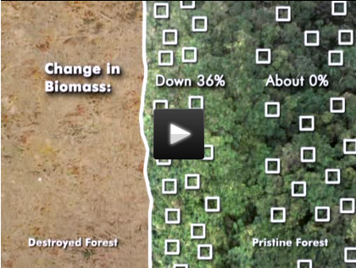

- Why are roads into the rainforests aptly described as “Pandora’s Box”?

- How do birds, who can fly great distances, deal with roads?

CORAL REEF Marine Ecosystem
- Two years after the oil spill, in the CONTROL AREAS, areas of study not affected by the initial oil contamination, what was observed?

- To what extent has the global population of large fish declined since 1950? Recall that it went from 10 fish per 100 hooks to 1 fish per 100 hooks, as per Japanese fishing data.

- How is the functional diversity of coral reefs described? In other words, what beneficial services do they provide?

- The absence of fish that allows for the overgrowth of seaweed can be shown in the picture below. How does this lead to the destruction of coral reefs?

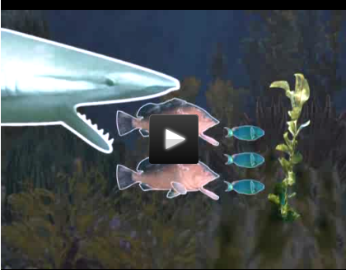
5. What is the “rise of slime”? And can coral reefs recover if left alone? Discuss…

