**CONCEPT 6 – REGULATION**

1. Feedback
2. Negative feedback mechanisms maintain dynamic homeostasis for a particular condition (variable) by regulating physiological processes, returning the changing condition back to its target set point.
3. Positive feedback mechanisms amplify responses and processes in biological organisms. The condition initiating the response is moved farther away from the initial set-point. Amplification occurs when the stimulus is further activated which, in turn, initiates an additional response that produces system change.
4. Cell-to-cell communication
5. Cells receive or send inhibitory or stimulatory signals from other cells, organisms or the environment.
6. In single-celled organisms it is response to its environment.
7. In multicellular organisms, signal transduction pathways coordinate the activities within individual cells. Ex. Epinephrine stimulation of glycogen breakdown in mammals
8. Cells communicate by cell-to-cell contact. Ex Immune cells interact by cell-cell contact, antigen- presenting cells (APCs), helper T-cells and killer T cells or plasmodesmata between plant cells that allow material to be transported from cell to cell.
9. Cells communicate over short distances by using local regulators that target cells in the vicinity of the emitting cell. Ex. Neurotransmitters, plant immune response
10. Signals released by one cell type can travel long distances to target cells of another cell type. Ex. Hormones
11. A receptor protein recognizes signal molecules, causing the receptor protein’s shape to change, which initiates transduction of the signal. Ex. G-protein linked receptors, ligand-gated ion channels, tyrosine kinase receptors.
12. Signal transduction is the process by which a signal is converted to a cellular response. Signaling cascades relay signals from receptors to cell targets, often amplifying the incoming signals, with the result of appropriate responses by the cell.
13. Second messengers inside of cells are often essential to the function of the cascade.
14. Many signal transduction pathways include: Protein modifications or phosphorylation cascades in which a series of protein kinases add a phosphate group to the next protein in the cascade sequence.
15. Gene Regulation
16. Prokaryotes
17. Inducers (turn genes on) and repressors (turn genes off) are small molecules that interact with regulatory proteins and/or regulatory sequences.
18. Regulatory proteins inhibit gene expression by binding to DNA and blocking transcription (negative control).
19. Regulatory proteins stimulate gene expression by binding to DNA and stimulating transcription (positive control) or binding to repressors to inactivate repressor function.
20. Eukaryotes
21. Transcription factors bind to DNA sequences and other regulatory proteins
22. Some of these transcription factors are activators (increase expression), while others are repressors (decrease expression).
23. The combination of transcription factors binding to the regulatory regions at any one time determines how much, if any, of the gene product will be produced.
24. Immunity
25. Plants, invertebrates and vertebrates have multiple, nonspecific immune responses, ex: phagocytes engulf and digest pathogens with the help of lysosomes
26. Mammals use specific immune responses triggered by natural or artificial agents that disrupt dynamic homeostasis.
27. The mammalian immune system includes two types of specific responses: cell mediated and humoral.
28. In the cell-mediated response, cytotoxic T cells, a type of lymphocytic white blood cell, target‖intracellular pathogens when antigens are displayed on the outside of the cells.
29. In the humoral response, B cells, a type of lymphocytic white blood cell, produce antibodies against specific antigens.
30. Antigens are recognized by antibodies to the antigen.
31. Antibodies are proteins produced by B cells, and each antibody is specific to a particular antigen.
32. A second exposure to an antigen results in a more rapid and enhanced immune response.
33. Viruses
34. Replication
35. Viruses inject DNA or RNA into host cell
36. Viruses have highly efficient replicative capabilities that allow for rapid evolution
37. Viruses replicate via the lytic cycle, allowing one virus to produce many progeny simultaneously
38. Virus replication allows for mutations to occur through usual host pathways.
39. RNA viruses lack replication error-checking mechanisms, and thus have higher rates of mutation.
40. Related viruses can combine/recombine information if they infect the same host cell.
41. Some viruses are able to integrate into the host DNA and establish a latent (lysogenic) infection
42. HIV is a well-studied system where the rapid evolution of a virus within the host contributes to the pathogenicity of viral infection.
43. Genetic information in retroviruses is a special case and has an alternate flow of information: from RNA to DNA, made possible by reverse transcriptase, an enzyme that copies the viral RNA genome into DNA. This DNA integrates into the host genome and becomes transcribed and translated for the assembly of new viral progeny.

***Vocabulary***

Antibody

Antigen

B-cell

Cell-mediated immunity

communication

cyclic AMP (cAMP)

cytotoxic T-cell

G-protein linked receptor

Helper T-cell

Hormone

Humoral immunity

Inducer

Lytic cycle

Lysogenic cycle

Negative feedback

Operon

Operator

Phagocyte

phagocytosis

phosphorylation cascade

positive feedback

protein kinase

receptor

repressor

retrovirus

reverse transcriptase

second messenger

signal cascade

signal transduction

signal transduction pathway

transcription factor

virus

white blood cell

***Thinking Practice***

1. Refer to the diagram at the right to respond to the following questions.
2. Is the hormone hydrophobic or hydrophilic? How do you know?
3. Explain how the action of the hormone might be different if it could move through the cell membrane.
4. Explain what is happening in this picture and make a prediction about what will be the end result in the cell to which this hormone has bound.
5. Lactose digestion in *E. coli* begins with its hydrolysis by the enzyme *b*-galactosidase. The gene encoding *b*-galactosidase, *lacZ*, is part of a coordinately regulated operon containing other genes required for lactose utilization. Use the legend below to draw the gene and its interaction with RNA polymerase, the repressor protein, and lactose when lactose is being digested.

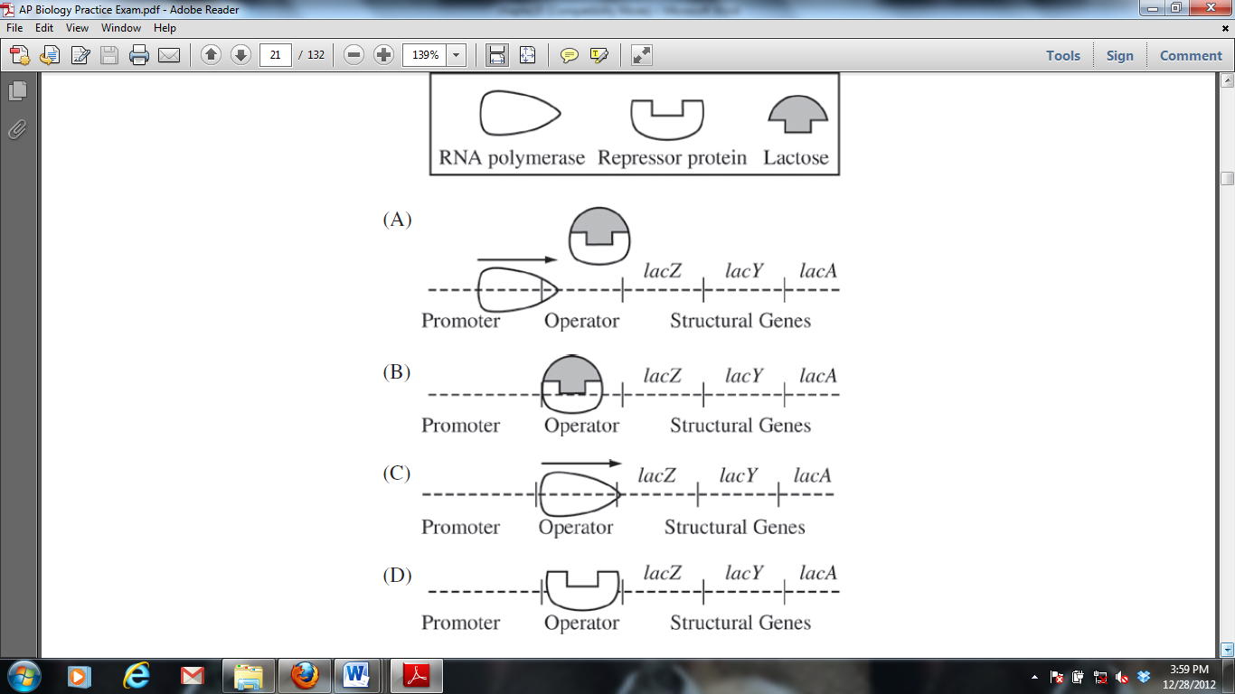

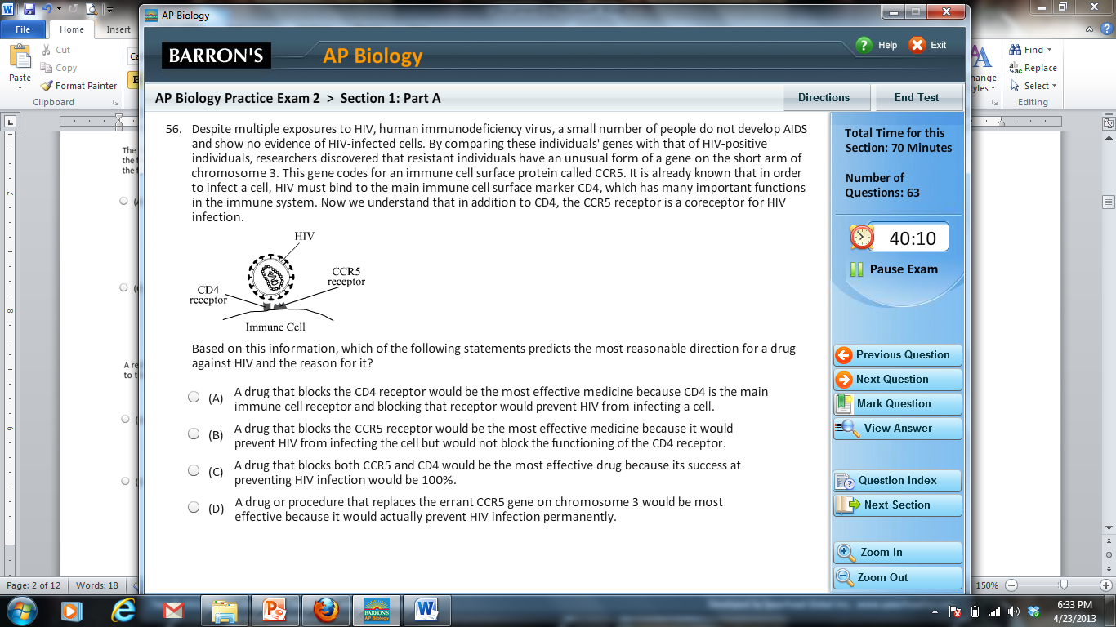

Based on the information provided, propose a possible mechanism for a drug to resist HIV infection.

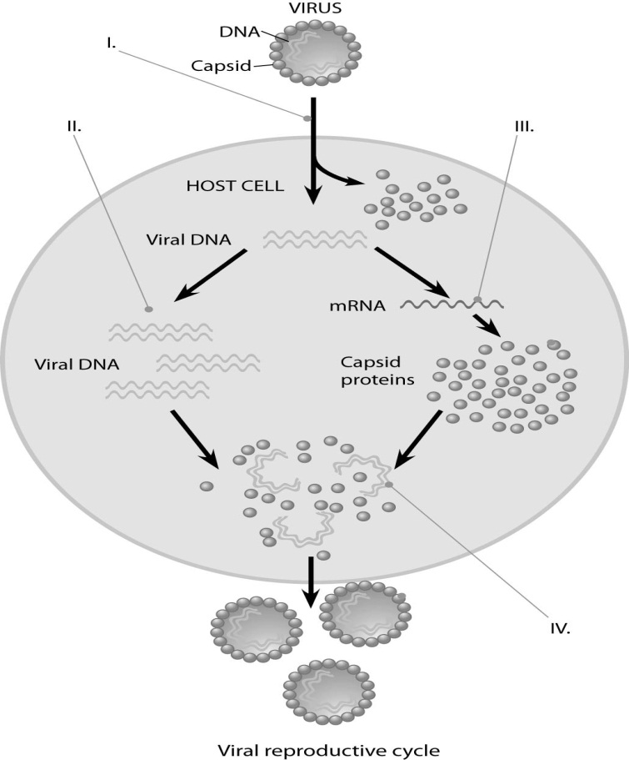

1. Describe the processes occurring at each of the numbered positions (I, II, III, and IV) in the diagram to the right.
2. Refer to the images at the right to answer the following:
3. Which immune response in shown: cell mediated or humoral? Explain how you know.
4. What are the “Y” shaped molecules called? What is their role in the immune response?



1. Describe how the “Y” shaped molecules relate to the graph displayed.
2. One student described an action potential in a neuron by saying “As more gates open the concentration of sodium inside the cell increases and this causes even more gates to open.” Is this an example of a positive or negative feedback loop? Justify your reasoning.



1. The figure to the right shows the feedback mechanism for regulating blood glucose.
2. Is this a positive or negative feedback loop? Explain your answer.
3. Individuals that suffer from Type I diabetes do not have functional insulin-producing cells. Describe how their blood will differ from that of a healthy individual after a glucose-rich meal.
4. In a molecular biology laboratory, a student obtained competent *E. coli* cells and used a common transformation procedure to induce the uptake of plasmid DNA with a gene for resistance to the antibiotic kanamycin. The results below were obtained.

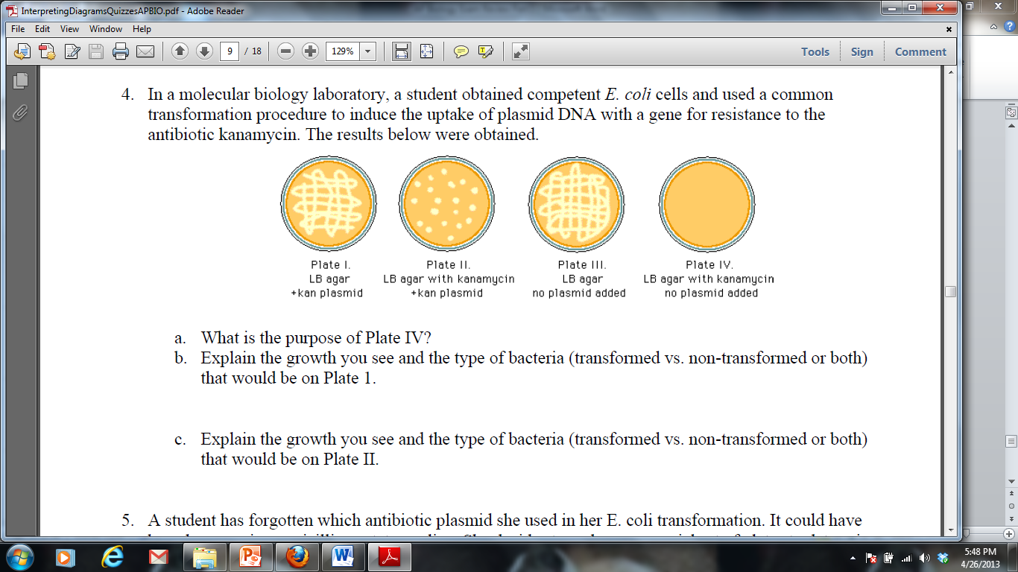

1. What is the purpose of Plate IV?
2. Explain the growth you see and the type of bacteria (transformed vs. non-transformed or both) that would be on Plate 1.
3. Explain the growth you see and the type of bacteria (transformed vs. non-transformed or both) that would be on Plate II.
4. If the student repeated the experiment, but the heat shock was unsuccessful and the plasmid was unable to be transformed, for which plates would growth be expected? Explain your answer.