CONCEPT 3 – ENERGY AND METABOLISM
- Energy
- Organisms use free energy for organization, growth and reproduction. Loss of order or free energy flow results in death.
- More free energy (ex. Food) than needed will be stored for growth (roots, glycogen, fat, etc.).
- Matter and energy are not created but change form (1st law of thermo; ex. Sun energy to bond energy in glucose) and entropy is increasing in disorganization of energy (i.e. heat released by cell respiration). More organized or built up compounds have more free energy and less entropy (i.e. glucose) and less organized have less free energy and more entropy (i.e. carbon dioxide).
- Reactions can be coupled to maintain a system, ex. Photosynthesis and cell respiration

- Cellular respiration C₆H₁₂O₆ + 6O26CO₂ + 6H₂O
- Makes ATP for cell use; uses glucose and oxygen makes waste products of carbon dioxide and water; occurs in mitochondria; NADH is electron carrier used
- Glycolysis
- occurs in cytoplasm; anaerobic
- rearranges the bonds in glucose molecules, releasing free energy to form ATP from ADP through substrate-level phosphorylation resulting in the production of pyruvate.
- Kreb’s cycle
- occurs in mitochondrial matrix
- also called the citric acid cycle
- occurs twice per molecule of glucose
- Pyruvate is oxidized further and carbon dioxide is released ; ATP is synthesized from ADP and inorganic phosphate via substrate level phosphorylation and electrons are captured by coenzymes (NAD+ and FAD).
- NADH and FADH2 carry electrons to the electron transport chain.
- Electron Transport Chain and Chemiosmosis
- The electron transport chain captures electrons, pumping H⁺ ions into the inter-membrane space of the mitochondria.
- Electrons are accepted by O₂ molecule forming H₂O
- Concentration of H⁺ builds up within inter-membrane space lowering the pH and ions rush through ATP synthase into the mitochondria matrix. Rush of ions “spins” ATP synthase protein, causing ADP and P_{i} to join forming ATP by oxidative phosphorylation

- Photosynthesis 6CO₂ + 6H₂O C₆H₁₂O₆ + 6O₂
- Photosynthetic organisms capture free energy present in sunlight and use water and carbon dioxide to make carbon products and free oxygen.
- Light-dependent reactions- photophosphorylation
- Photosystems I and II (chlorophyll and proteins) are embedded in the internal membranes of chloroplasts (thylakoids of the grana). They pass electrons through an electron transport chain (ETC). When electrons are passed they allow hydrogen ions (protons) across the thykaloid membrane. The formation of the proton gradient powers the process of ATP synthesis to add a phosphate ADP to ATP (chemiosmosis).
- Electrons are passed to NADP+ to make NADPH (electron carrier)
- H₂O is used and O₂ released as by-product
- Red and blue light works best (green is reflected typically)
- Energy converted from sun into chemical energy of ATP and NADPH to be used in building of sugar (Calvin Cycle)
- Light-independent reactions- Calvin Cycle
- carbon fixation occurs (carbons of CO₂ used to make sugar)
- occurs in stroma of chloroplasts
- ATP and NADPH generated by light-dependent reactions are used to assemble glucose

- Anaerobic Fermentation
- No oxygen; cell only goes through glycolysis followed by fermentation
- Fermentation recycles NAD needed to restart glycolysis
- alcohol fermentation ex. yeast cells- glucose ethyl alcohol + CO₂+ NAD⁺
- lactic acid fermentation ex. muscle cells- glucose lactic acid + NAD⁺
- Fermentation does not make ATP but glycolysis does- 2ATP; very inefficient; sufficient for microorganisms

Vocabulary

absorption spectrum
acetyl coA
anabolism
anaerobic metabolism
ATP
ATP synthase
autotroph
Calvin cycle
cellular respiration
chemiosmosis
chlorophyll
chloroplast
citric acid/Krebs cycle
electron transport chain
FAD/FADH₂
feedback inhibition
fermentation
glycolysis
light dependent reactions
light independent reactions
metabolic pathway
mitochondrion
NAD/NADH
NADP/NADH
oxidative phosphorylation
photolysis
photosynthesis
photosystem I
photosystem II
pyruvate
stroma
substrate-level phosphorylation
thylakoid membrane

Thinking Questions
- The figure below outlines the process of cellular respiration. Glucose and oxygen are both reactants in this process.
- Describe the journey of a single carbon atom from glucose in cellular respiration

- Describe the journey of a single hydrogen atom from glucose in cellular respiration

- Describe the function of the oxygen molecules in cellular respiration

- The figure below outlines the process of photosynthesis. Carbon dioxide and water are both reactants in this process.
- Describe the journey of a single hydrogen atom from water in photosynthesis.

- Describe the journey of a single oxygen atom from water in photosynthesis.

- Describe the journey of a carbon dioxide molecule in photosynthesis.

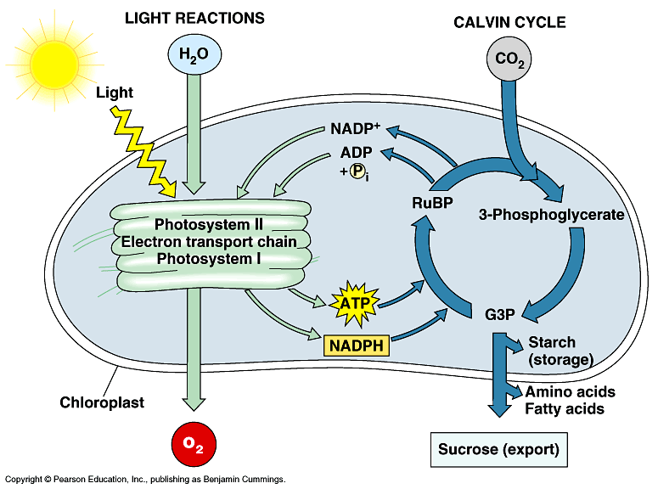

- It is estimated that more than 2 × 1026 molecules of ATP are hydrolyzed in the human body daily. If each molecule was used only once you would need approximately 160 kg (350 lbs) of ATP daily. The repeated use of ATP molecules through the ATP cycle saves the body a huge amount of resources and energy.
ATP is synthesized in two ways:
- Substrate-level phosphorylation—Energy released during a reaction, such as the breakdown of sugar molecules, is used directly to synthesize ATP. A small amount of energy is generated through this process.
- Electron transfer (oxidative phosphorylation)—Energy from the movement of electrons from one molecule to another, via electron carriers, is used to synthesize ATP. Most cellular ATP is synthesized by electron transfer in the mitochondria.

Dinitrophenol (DNP) is an “uncoupler,” which means it interferes with the flow of electrons during electron transfer. Fifty years ago, DNP was given as a drug to help patients lose weight.
- Why would taking DNP make someone lose weight?

- Why would taking DNP be dangerous?

- An experiment to measure the rate of respiration in crickets and mice at 10ºC and 25º C was performed using a respirometer, an apparatus that measures changes in gas volume. Respiration was measured in mL of O₂ consumed per gram of organism over several five-minute trials and the following data were obtained.

- Which organism at which temperature had the fastest metabolic rate (produced the most ATP) during its trials? Explain how you know.

- According to the data, the mice at 10ºC demonstrated greater oxygen consumption per gram of tissue than did the mice at 25ºC. Propose an explanation for why this is.

- Under laboratory conditions, muscle cells were broken up and separated into fractions of mitochondria and cytoplasm in an attempt to learn more about cellular respiration. Each fraction was incubated with glucose or pyruvate. Tests were carried out during incubation for the presence of either carbon dioxide or lactic acid. The results are shown below:
- What does the presence of lactic acid in a sample indicate about what process is occurring in each cell fraction?

- Explain why lactic acid was produced by the cytoplasm fraction incubated with glucose, but not the mitochondrial fraction.

- Why was no carbon dioxide produced by either fraction incubated with glucose?

- Why did the cytoplasm fraction produce lactic acid in the presence of both glucose and pyruvate?

- Why did the mitochondria produce carbon dioxide in the presence of pyruvate but not in the presence of glucose?

- The figures to the right display the absorption range for several different pigments found in plants (top) and the rate of photosynthesis at varying conditions of wavelength in one plant species (bottom):
- What color and wavelength of light is reflected by the plant species tested? How do you know?

- What wavelength(s) increase the rate of photosynthesis in the plant species tested? What pigment does this correspond to? How do you know?
Energy and Metabolism Short Free Response (4 points)
In a second experiment, Variety A seedlings at 17ºC were treated with a chemical that prevents NADH from being oxidized to NAD+. Predict the most likely effect of the chemical on metabolism and oxygen consumption of the treated seedlings. Explain your prediction.

